**SQL Assignment**

**Tasks:**

Create the world database and answer the following.

1. Produce schema diagram.



1. Using count, get the number of cities in the USA

Ans: 274 cities

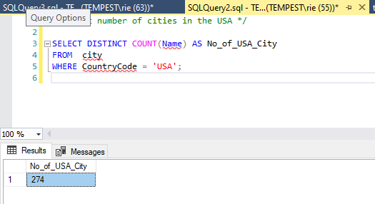

1. Find out what the population and average life expectancy for people in Argentina (ARG) is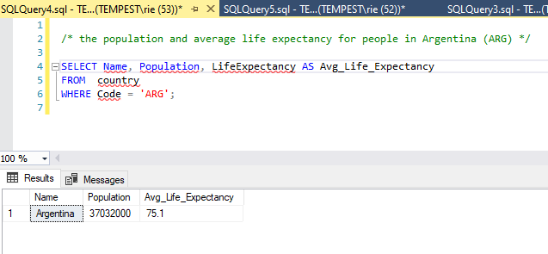
2. Using ORDER BY, LIMIT, what country has the highest life expectancy?

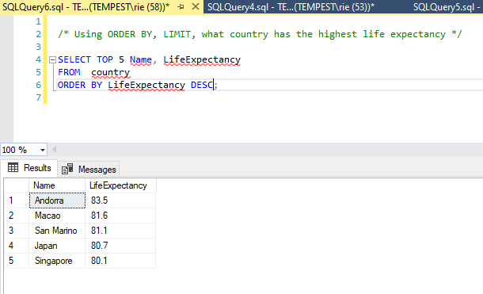

1. Select 25 cities around the world that start with the letter 'F' in a single SQL query.

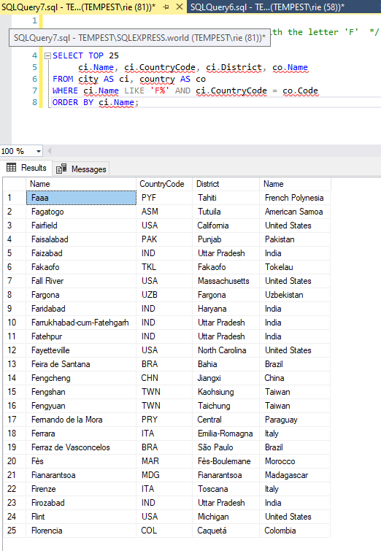

1. Create a SQL statement to display columns Id, Name, Population from the city table and limit results to first 10 rows only.

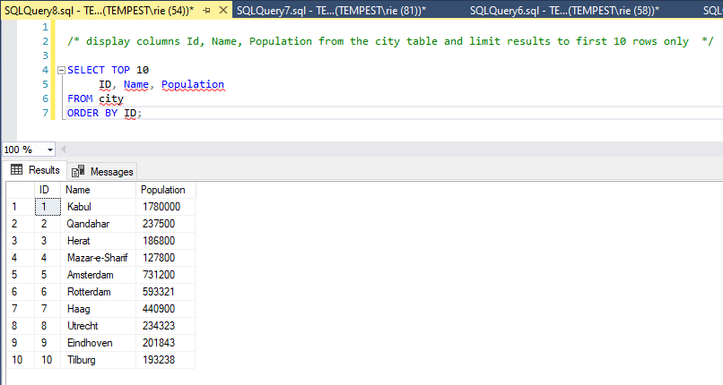

1. Create a SQL statement to find only those cities from city table whose population is larger than 2000000.

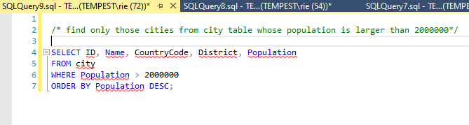

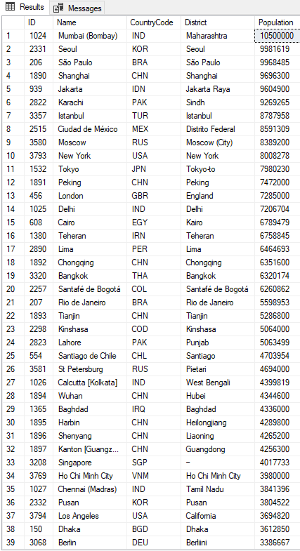

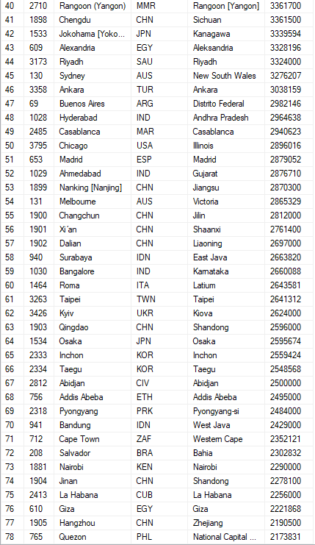

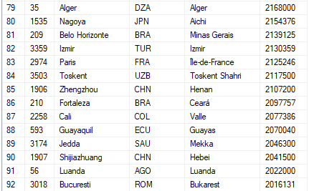

1. Create a SQL statement to find all city names from city table whose name begins with “Be” prefix.

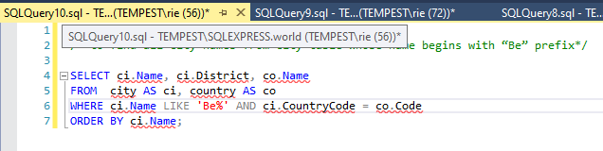

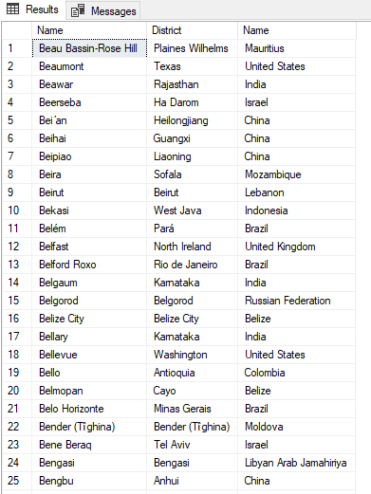

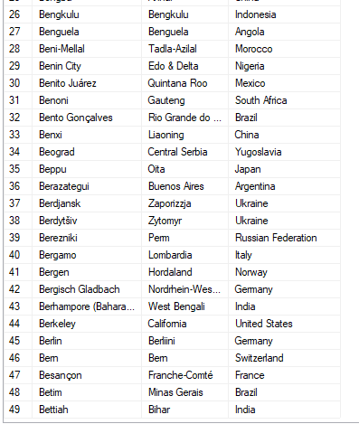

1. Create a SQL statement to find only those cities from city table whose population is between 500000-1000000.

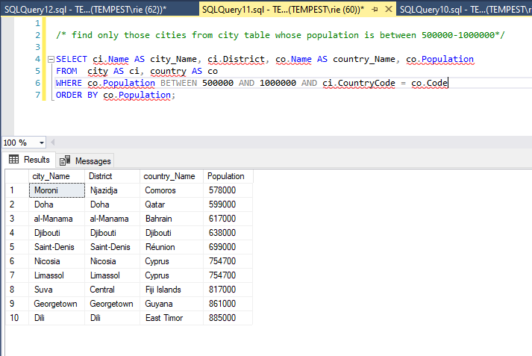

1. Using LEFT JOIN, ON, what is the capital of Spain (ESP)?

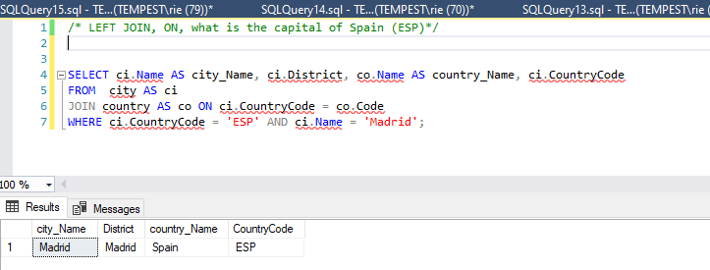

1. Using LEFT JOIN, ON, list all the languages spoken in the 'Southeast Asia' region

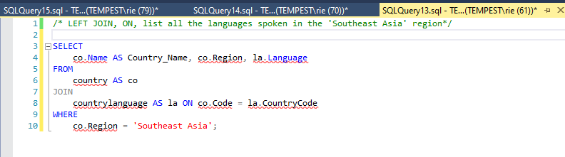

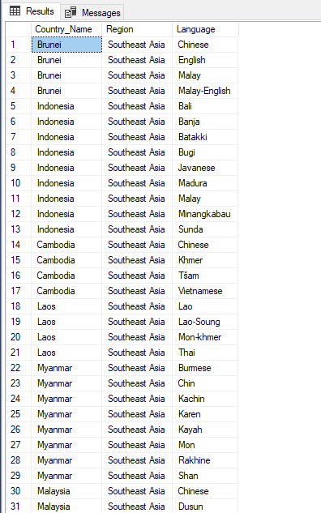

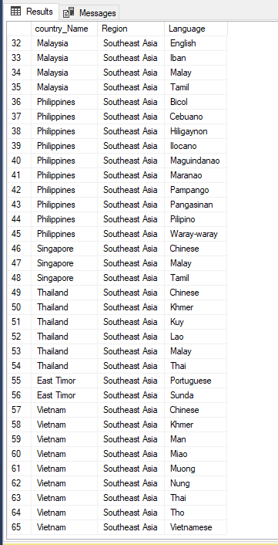

1. Create a SQL statement to find a city with the lowest population in the city table.

